Walk, look, remember. Art galleries as spaces facilitating memory

ABSTRACT
The spatial organisation of museums has been a subject of numerous studies. Previous research, however, despite reporting some actual behavioural correlates, rarely had the possibility to investigate the cognitive processes of the visitors. In the museum context, where spatial layout is one of the most powerful curatorial tools available, we focus on measuring attention and memory as a means of establishing whether the gallery fulfils its function as a space for contemplating art. In the experiment, 32 participants split into 2 groups explored an experimental, non-public exhibition space whilst wearing a portable eye-tracking device and completed two unanticipated memory tests. The results show that some spatial characteristics of an exhibition can inhibit recall of pictures and shift the focus to perceptual salience of the artworks.

INTRODUCTION
It is difficult to establish what constitutes a good museum/gallery exhibition. Yet, it has been widely acknowledged, that what visitors attend to (Serrell 1997; Bitgood 2010) and what they 'get out of it' (Vergo 1989, p.46) should be a priority. To facilitate that, the curators' main task lies in presenting the exhibited material within the space available. The spatial location of exhibits must inevitably add meaning to the objects, which often goes beyond the original intentions of the artist (Baxandall 1991). Being aware of the space's characteristics, possibilities and limitations is therefore crucial when designing an exhibition with its visitors in mind (Newhouse 2005). The task appears even more difficult when the fact that the museum was probably designed by a third party (the architect, no longer engaged with it and holding different conceptions/priorities of space use) is taken into account. Therefore, since museum visitors are those for whom these spaces exist in the first place, providing exhibition designers and curators with tools to understand and control the influence of the 'already-existing-spaces' upon the final experience of their visitors is a goal which could also serve in the design of new galleries in the future.
From the cognitive point of view, the processes which are the most relevant to consider in this context are visual attention and memory. Visual attention is often held to be a bottom-up directed process, driven by the external features of the environment, such as the objects' salience (Itti and Koch 2000). However, growing evidence shows that instead of being automatically shifted based on the visual properties of the outside world, our visual perception might be guided by higher cognitive processes to regions where information might be acquired for a current goal to be accomplished. This is known as the top-down strategy (Land and Tatler 2009). In this case, an art gallery is an ideal research setting where viewing (and therefore, as we show later, spontaneous learning) of objects and their spatial relations is an obvious aim of visiting such places. If indeed higher cognitive functions guide our visual attention, finding a real-life context in which these cognitive goals would be equivalent among most of building users eliminates a large chance of confounding the study. If so, art galleries can be very elegant environments for investigating the influence of space on human cognition. A finding showing that a dynamic spatial experience is much superior in an object memorisation task than memorising the list of those objects (Buchner and Jansen-Osmann 2008) suggests that museum spaces are, for our cognition, more than simply neutral white cubes (see O’Doherty 1986 for the discussion on the subject). There must be something about the spatial experience of exhibitions that makes it more preferable compared with viewing the same artworks in a printed catalogue from the comfort of one's own living room (Newhouse 2005; Baxandall 1991). Disentangling this experience and comparing it to the existing research in cognitive psychology, with the emphasis on its spatial predictors, is the main challenge of this work.
The mechanisms of spatial cognition which guide our exploration of space and spontaneous memory of encountered objects have been largely investigated in the landmark literature. If landmarks are defined as easily recognisable objects serving as a point of reference in space (Chan et al. 2012) and if we assume that their acquisition is spontaneous (Chan et al. 2012; Janzen and van Turennout 2004) then the findings from these studies could be applied to artworks in a gallery space. It is unquestionable that even during a free exploration of an art gallery, visitors must still use their spatial abilities to orientate themselves in space. If this was not true, the behaviour of visitors in a museum space would be random, with no mechanisms helping them to avoid revisiting previously explored rooms, to attend to novel spaces, and eventually to find one's way out. Viewing art in a museum must be inextricably bounded with acquiring knowledge about spatial location of certain objects and the overall gallery's layout. An additional important advantage of this research is that they make a distinction between object-based and location-based attention (Caduff and Timpf 2008) resulting in the knowledge of objects and knowledge of the spatial relations between them (Montello 1998), which is also often referred to as the memory within the egocentric and allocentric frames of reference (e.g. Han et al. 2012).
For instance, Janzen (Janzen 2006) observed that in a virtual museum, objects placed next to decision points (junctions) are recalled faster on a computer-based recognition task than those which were placed along straight paths. The author suggested that this effect might be the result of a linkage between the representation of a particular object with the representation of its location in the participants' memory. This explanation would be in line with different neural activity patterns in the parahippocampal gyrus (responsible for place-object mapping), which can be induced by decision-point-based and non-decision-point-based objects (Janzen and Van Turennout 2004). Subsequently, in their study, Miller and Carlson (Miller and Carlson 2011) designed a similar virtual museum, but in addition aimed to take the objects' perceptual salience into account. For this reason, objects placed inside were separately rated for their perceptual salience by an independent group of participants. The authors managed to replicate Janzen's (Janzen 2006) results when objects of high perceptual salience were placed on decision points, but did not, when highly salient objects were purposefully placed on navigationally irrelevant locations (i.e. on non-decision points). In the latter variation of the experiment, high perceptual salience appeared as the factor enhancing response times on the computer-based recognition test, while navigational relevance guided participants' responses in map drawing and route description tasks. As the authors conclude, the encoding of a landmark (object) might be driven by its perceptual features, whereas its selection during spatial tasks seems to be driven by its spatial features (Miller and Carlson 2011). This shows the importance of separating the object-oriented memory from location-oriented memory, as measured by different types of tasks. In this case, a computer-based recognition test was shown useful for establishing the memory trace of particular objects and spatial tasks for assessing the location-oriented memory. Miller and Carlson's (ibid.) results also suggest that the former should be highly dependant on the objects' salience, while the latter should remain unrelated to it. However it must be noted at this point that the patterns of spatial cognition, especially the process of selecting navigationally relevant objects highly vary depending on the actual context, as well as goals and strategies of the individuals (Steck and Mallot 2000) and therefore it is difficult to generalise similar results across different contexts. This is especially the case when considering how many spatial tasks are used in the literature and that their relations with each other are not always clear. This problem has been emphasised in the work of Caduff and Timpf (Caduff and Timpf 2008), who proposed a three-level Saliency Vector for assessing the salience of landmarks based on their perceptual, cognitive and contextual aspects (Caduff and Timpf 2008).
Yet, since the aforementioned studies stayed within the museum context, it seems valid to treat pictures hanging on gallery walls as landmarks, for the purpose of the further analyses. This can be justified by the fact that it is a natural goal for a gallery visitor to direct one's attention to these objects and in a visually ascetic space they remain the most salient reference objects for navigation. The spatial relations between them can also, either consciously or spontaneously, become a component of the viewer's understanding of curatorial intentions. It therefore can be concluded that a gallery visit incorporates both types of attention: object-based and location-based, which induce memory traces of the individual objects, as well as of the spatial relations between each other. The former type of memories could be explained as mainly (but not exclusively) influenced by a picture's salience, when the latter remains solely the effect of the curatorial narrative (Psarra 2009) and is facilitated by the interpersonal differences in perception and experience (Baxandall 1991; Steck and Mallot 2000).
If this provides a deeper understanding of the visitor's experience, how can space be used to influence it? Curators have developed many strategies of displaying art, and it would be wasteful to ignore this input. Previous research in Space Syntax took art galleries into consideration and there is a large number of real-life case studies available, which investigated different approaches to space arrangement in the museum context. The use of space in curatorial narrative has been analysed on the level of global properties of the whole galleries, as well as the local spatial characteristics of specific artworks. The former type of analyses showed for instance, how the way knowledge is transmitted can be reflected in the spatial logic of the exhibits (Peponis and Hedin 1982). A wide interest has been given to the global layout and the resulting effects, such as visitor movement patterns (Hillier et al. 1996), or categorical segregation of artefacts and syntactic intelligibility of the building (e.g. Choi 1999; Kaynar 2005; Psarra 2009; Zamani 2009; see Hillier and Tzortzi 2007 for an overview).
However the focus of this paper is mainly on the local properties of artworks' locations which determine their spatial, and as a consequence - curatorial, relationships. In this context, the concepts of isovist (Benedikt 1979) and visibility graph analysis (VGA; Turner et al. 2001) underly the main relevant analyses. Tzortzi (Tzortzi 2003) for example, showed how the placement of pictures and the overlap of their visual fields can be used in the creation of the final gallery experience. These spatial practices can also, in sum, distinguish those museums imposing some pre-defined meaning upon the visitor's interpretation, and those which allow for more unrestricted explorations (Tzortzi 2007). Further, Stavroulaki and Peponis (Stavroulaki and Peponis 2003) suggested that the positioning of artworks is an important factor influencing paths taken and, as a result, the final experience of the visitors. Since looking at sculptures and paintings is the main goal of a museum visit, most visitors will attempt to position themselves within a comfortable viewing position in front of these works. An isovist restricted to a 60 degree visibility cone is suggested as such a catchment area (Stavroulaki and Peponis 2003). Therefore the spatial position of artefacts in a museum must have a behavioural effect upon visitors which results in a different experience on the cognitive level. A link towards the empirical confirmation of these suggestions has already been made by Wineman, Peponis and Conroy Dalton (Wineman, Peponis, and Conroy Dalton 2006), who measured the sequence of visitors' engagement with the same science exhibits in a differently organised spatial environments. They hence emphasise that the cognitive effect of spatial exhibition design goes far beyond the curatorial narrative and can be an independent medium for constructing the meaning. Our paper answers to the explicit call for further empirical studies verifying assumptions of the exhibition design's influence on various aspects of human cognition.
In an experimental setup, Wiener et al. (Wiener et al. 2007) showed already how isovist properties are related to participants' navigational behaviour and environmental ratings. This however differs from our approach by the selection of isovist's generating points, which in this case have been avaraged for the whole environment, as an indication of general feel of the whole space. Methodologically closest to our concept is another experiment, deriving from Human-Computer Interaction studies (Dalton, Marshall, and Conroy Dalton 2010), where the influence of various isovist properties on the memory of passers-by was assessed. The isovists in this case were generated from the location of a public multimedia display at which the stimuli were presented. Results showed that pictures might be more memorable than words if presented within a large isovist area and words are more memorable than pictures if presented within small isovist areas. Additionally, images proved to be easier memorised if presented in spiky isovists compared to round, or more convex isovists. Despite the preliminary character of the study, this suggests that the spatial properties of a location of the displayed visual stimuli might significantly influence the way it is received by the building users. More conclusive assumptions would, however, require a stricter control over the experimental environment.
To take both visual attention and memory into account, a study was designed in which participants explored an especially designed art gallery whilst wearing a mobile eye-tracking device and than took part in unanticipated memory tests. We report the eye-tracking results elsewhere (reference anonymised) and focus on spatial correlates of memory in this paper.

METHOD

Method Outline
Testing human memory for objects in a real-life environment always carries the risk of confounding effects. Many factors contribute to the interest taken in a particular object and not all factors can be measured. Concurrently, if the goal is to imitate the actual experience of an art gallery visit, trying to control these factors by constraining the participants to follow a predefined route within a strict timeframe, or showing them a video of the route instead, would severely differentiate the experiment from the real-life situation. Besides, the diversity of exploration possibilities is what makes a museum visit different from seeing the same artworks in a printed catalogue from the comfort of one's own house. To account for this freedom of behaviour, a study was designed which allowed to maximise the control over the environmental conditions while still remaining as close to the real visit in an existing art gallery.

Space and Materials
Images used for the study were artworks of equal dimensions (portrait-oriented A3), created by Susi Bellamy, a MA student in Fine Arts . A private art gallery was arranged in a building otherwise used as a project studio and exhibition space for Fine Arts students. Two experimental conditions were designed, which differed by the spatial arrangement of the locations of pictures hanging on the gallery walls (Figure 2).
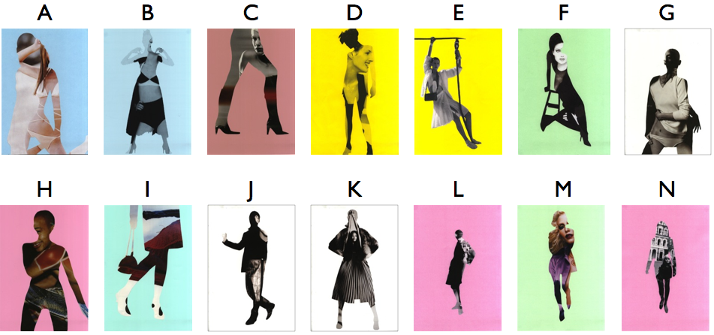
Figure 1. Pictures used in the study and the letters used for their identification in subsequent analyses.

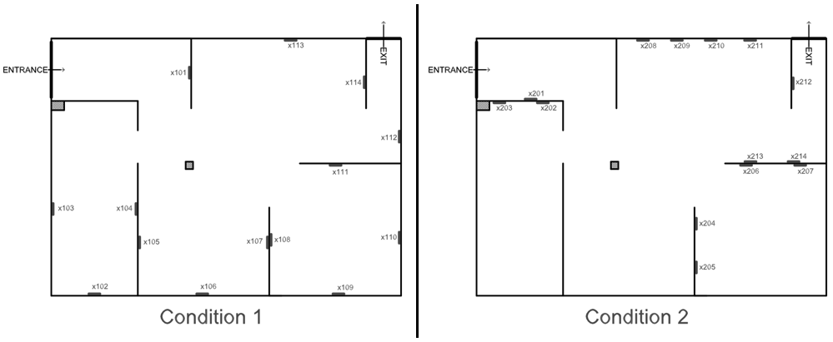
Figure 2. Spatial layout and the location names in two experimental conditions.

Participants
Thirty two participants, 13 female and 19 male, aged between 18 and 63 years (M = 30.75, SD = 11.73) with normal or corrected-to-normal vision were recruited through the university email system and local job-seekers internet discussion forums for a fee of £6. Before the experiment started, a short excerpt from a test for normal colour vision was administered to confirm the participant's self-declaration (Ishihara 1917). Standard ethical procedures were employed throughout the study.
One participant declared the previous familiarity with the space in which the experiment was conducted. Numerous wayfinding research had shown the influence of previous knowledge on spatial memory (e.g. O’Neill 1992; von Stülpnagel and Steffens 2012) and we therefore decided to remove the participant from all subsequent analyses. Concurrently it could be argued however, that since goals drive the visual attention (Land and Tatler 2009) and the subsequent perception of traveled space (Johnson 2011), every visit to a gallery containing a new exhibition is a novel visual experience and since it was not the wayfinding performance that was studied, but the knowledge of the exhibition, the effect of environmental familiarity should be weak. Yet, our sample size was too small and not diverse enough to determine that.

Procedure
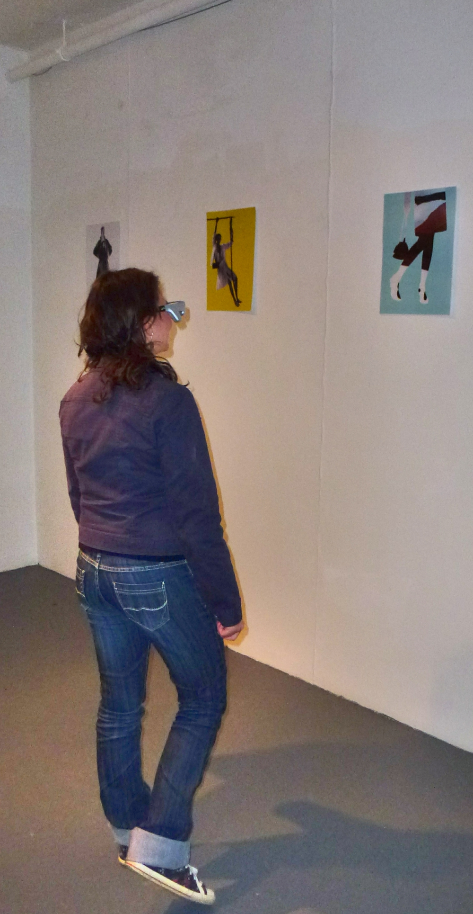
Participants were randomly assigned to Condition 1 (N = 14), or Condition 2 (N = 17 after the subsequent removal of the person familiar with the space from the dataset). Wearing a Tobii eye-tracking device they were asked to enter the main part of the gallery and to 'explore it just as you would explore a regular art gallery' within the time limit of 30 minutes (Figure 3). After exiting the gallery a buffer task was administered to the participants, which involved filling in a payroll form with their bank details for the payment purposes. Following that an unanticipated object recognition test (similar to the one used by Janzen 2006 and Miller and Carlson 2011) was presented (Mathôt, Schreij, and Theeuwes 2012) on a laptop with two keys labeled as 'YES' and 'NO'. Subjects were instructed to answer whether they saw the displayed picture in the gallery or not. Accuracy and speed were emphasised in the instruction. Images were shown one at a time in a random sequence and each was preceded with a fixation cross on a blank screen lasting for 250 ms. Three additional, unrecorded objects were shown at the beginning of the test for the purpose of procedural training. All 14 pictures presented in the gallery were included, with another 14 being new (either completely new or modified versions of the pictures seen in the gallery). Reaction times and yes-no accuracy were recorded.
Figure 3. A simulation of the experimental procedure.
After completing the recognition test, the participants were asked to move to a table where a different task was presented to them similar to Tour Integration Task (Münzer et al. 2006; von Stülpnagel and Steffens 2012). They were shown a printed layout of the gallery they had visited and miniature versions of the pictures from the inside. The instruction was to arrange the miniatures on the printed floor plan as they were set out in the gallery. No time limit was suggested. Figure 4 shows a sample solution.
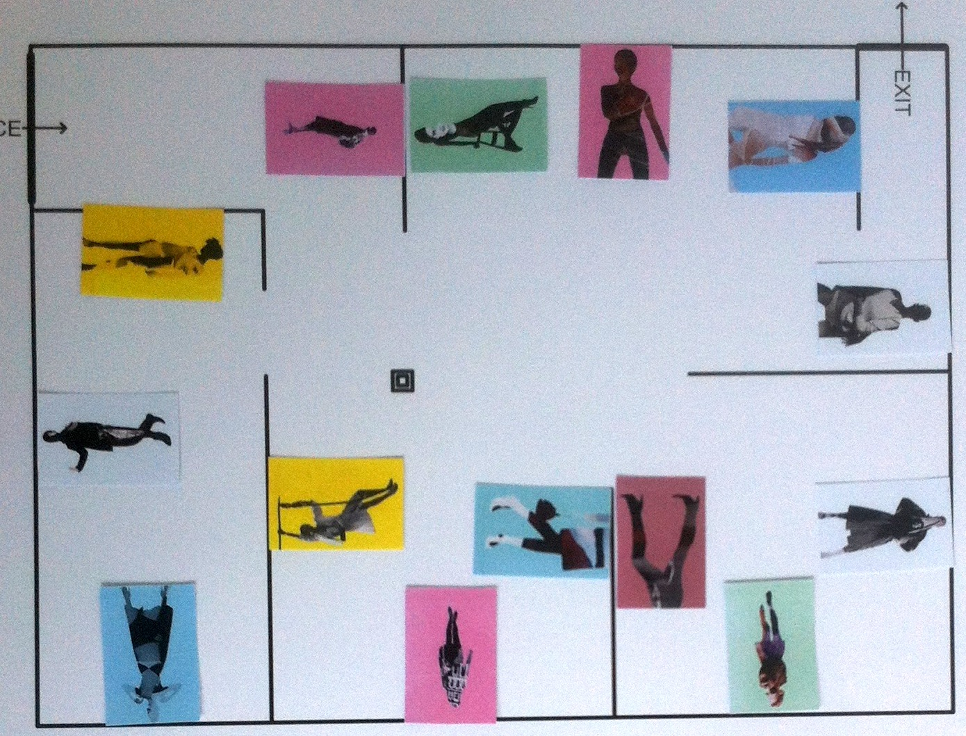
Figure 4. A sample solution of the Miniature Task.

Experimental Design
As seen previously in Figure 2, spatial arrangement of picture locations differed the 2 conditions. This however would not be sufficient to infer of the spatial layout's influence on human attention and memory, since what people pay attention to might result from the interaction of its spatial prominence and the stimulus' salience. In order to separate the effect of space from the effect of picture salience, the sequence of the pictures seen inside the gallery was randomised for each participant. Therefore each visitor had seen the same pool of pictures (Figure 1), on the same set of locations (Figure 2), but in a unique, random combination. This allowed for recording the memory performance twofold: as a picture-oriented and location-oriented variable. As a result, it could be concluded, for instance, that 'Picture K generated shorter Response Times (RT) than picture F' (for picture-oriented variable), but also, that 'Pictures placed on Location x108 generated shorter RT than those from Location x105' (for location-oriented variable). Statistical significance of this relations can be established independently for pictures and locations, allowing for the deconstruction of space-salience interaction. It was hypothesised, that significant correlation of location-oriented memory variables and the spatial properties of those locations would prevail, despite the influence of individual pictures' salience.

Salience Study
To further allow for salience of the pictures used in the gallery, a separate online experiment was conducted on an independent group of 54 participants. The procedure was designed to imitate the one described by Miller and Carlson (Miller and Carlson 2011). Participants were presented the pool of 14 pictures used in the gallery study and asked to 'drag & drop' them on the screen according to 'how much they draw your attention'. Because this method would not be feasible for a large number of visual stimuli presented simultaneously on a small computer screen, pictures were displayed in two sets of three and two sets of four. The order of the displayed pictures was fully randomised, and the content (i.e. the neighbourhood of other pictures in which each picture appeared) was quasi-randomised in 4 experimental blocks.

DATA ANALYSIS
All statistical analyses were conducted using the R package (R Core Team 2013).

Reaction Times
For Reaction Time data only the correct 'yes' answers were taken into consideration (78% of the whole data set). The individual accuracy of the responses was also recorded and will be referred to as 'RT accuracy'.
When the reaction times are considered, the outliers have always been an issue in the analyses of ex-Gaussian distributions, and various approaches to their removal are proposed. According to widely supported recommendations (Ratcliff 1993; Whelan 2008) a cut off of 2 standard deviations from the mean of the whole dataset was employed. This was equal to 3372 ms and disregarded further 9% of the observations leaving 69% valid (i.e. correct and lying within 2 SD) responses. No reactions below the threshold of physical possibility (200 ms according to Whelan 2008) were observed. The mean of all valid reaction times calculated for each participant constituted a personal mean RT. These personal means were later subject to cross-condition comparisons. Mean RT were also independently calculated for each picture (Figure 5) and for each location (Figure 6).
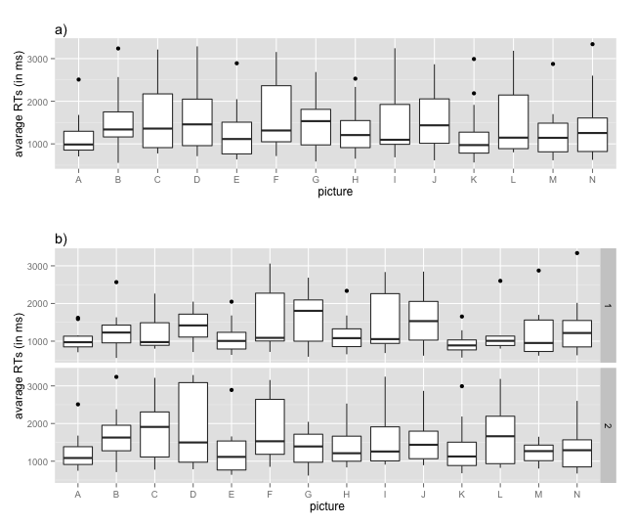
Figure 5. Mean Reaction Times (in milliseconds) as a picture-oriented variable calculated a) jointly for both conditions and b) for each condition separately. Lower means indicade 'better' (quicker) recall.

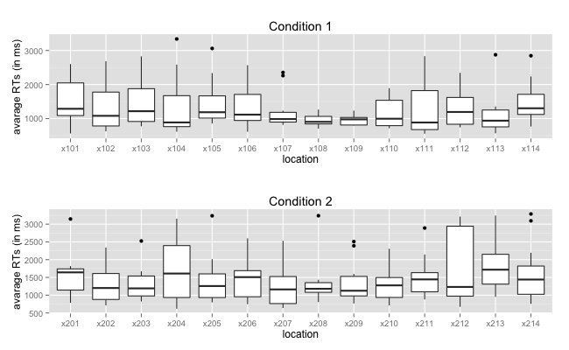
Figure 6. Mean Reaction Times as a location-oriented variable.

Miniature Task ('Back-to-the-Wall' measure)
After each participant declared finishing the Miniature Task, a picture of the solution was taken for further analysis (Figure 4). The solution of one participant from Condition 1 suffered data loss. The remaining photographs were subject to further analysis. The position of each miniature was first compared to its true location inside the gallery for the given participant. If the participant placed it anywhere along the wall on which the given picture was in fact located, participant scored 1 point for this picture. Otherwise 0 was given. Mean personal scores from this task (i.e. a number of correctly placed pictures divided by their number: 14) were used for cross-condition comparisons. Additionally, mean scores for each picture were calculated equal to the number of correct answers divided by the number of participants. Furthermore, the data was recoded as a location-oriented variable. That is to say, the name of each picture was changed into the name of the location at which it was positioned for the given participant and all analyses repeated. This allowed to calculate mean Back-to-the-Wall measures for each location (similarly to Section 3.1, Figure 5, and Figure 6).

Salience Rating
Out of 54 participants who took part in the independent salience study, 14 were removed due to not finishing the survey, outlying engagement time or no 'drag & drop' action taken on at least one of four picture sets. The results of the remaining participants (N = 40; 22 female; mean age = 28.74, SD = 8.06; mean time spent on the survey = 189 sec., SD = 64 sec.) were calculated in the following way: for being dragged to the first position within a set, a picture was given score of 1. For being placed 2nd, 3rd and 4th the scores were .66, .33 and 0 accordingly for 4-picture sets. For the 2nd and 3rd position in a 3-picture set .5 and 0 points were given. Mean score of each picture was pulled from the positions given to it by each participant and this constituted the Salience Rating falling between the range of 0 and 1. In this case a mean of 1 would indicate that every participant dragged the picture to the first position along its neighbours. Mean 0 would show that all participants placed the object at the bottom of the set in which it was seen.

Space Syntax Measures
Spatial properties of each locations were derived using Depthmap 10.14.00b (Turner 2001). The software was used for Visibility Graph Analysis (VGA; Turner et al. 2001), as well as to calculate the Boundary Visibility Graph (BVG; which is a VGA calculated for the grid cells lying along the walls only) and various isovist properties generated from each location. For each location two additional variables were derived: the number of other pictures present within the isovist generated from the given location and Visibility Catchment Area (VCA). The latter measure is equivalent to the area of an isovist generated from each location, but restricted by a cone of 60 degrees (Stavroulaki and Peponis 2003). However, please note that the area of comfortable visibility can be interpreted as a more complex issue (Xie et al. 2007; Schmidt, Müller, and Bailly 2013). Figure 7 presents a visual example of few major analyses.

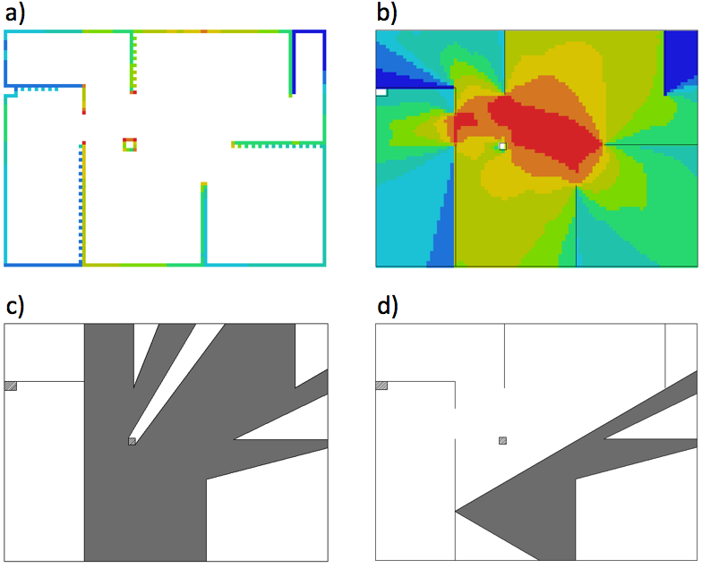
Figure 7. Some spatial analyses used in the study: a) Boundary Visibility Graph - BVG, b) Visibility Graph Analysis - VGA, c) sample isovist derived for location x105;
d) sample Visibility Catchment Area - VCA, derived for location x105.

RESULTS

Time Spent Inside
The personal performance on memory tests increased as the total time spent inside increased, but only for those participants who were inside for less than 9 minutes. Spearman's rank correlation coefficient indicated a nonlinear relationship of the time spent inside and Back-to-the-Wall results (i.e. the Miniature Task): r_{s}(31) = .55; p < .01, as well as RT accuracy, r_{s}(31) = .61; p < .001.

Memory Performance: Condition 1 vs. Condition 2
From all memory measures, only the difference in the personal means of RT were significant, as indicated by Welch's t-test t(25.5) = 2.19; p < .05 with participants from Condition 1 reacting faster (M = 1277 ms, SD = 296) than those from Condition 2 (M = 1620, SD = 552).
No significant difference in RT accuracy was found, similarly to other studies using this measure (e.g. Hollingworth 2008; Miller and Carlson 2011).
A very large spread of Back-to-the-Wall results within Condition 2 did not allow us to investigate the cross-condition difference. A similar situation occurred in other studies with different tasks measuring spatial knowledge and might be indicative of its very high difficulty in the given context (von Stülpnagel and Steffens 2012).

Spatial Differences Between the Conditions
Figure 2 shows the arrangement of picture locations for each of the 2 conditions. Since everything else in this space was unmodified, this arrangement is the only independent variable distinguishing the two experimental situations. This puts spatial properties of the locations at the centre of interest and allows us to link them with the significant difference in RT scores.
In order to quantify these spatial differences between Condition 1 and Condition 2 (Figure 2), their mean spatial properties were derived and compared across conditions. From all spatial metrics analysed so far, two of them distinguish the conditions to the largest extent and seem theoretically relevant for explaining the variation of memory results. First, mean VCA for each location was larger in Condition 1 (M = 117464, SD = 63268) than in Condition 2 (M = 99261, SD = 69807). Second, the mean number of other objects within single location's isovist polygon was larger in Condition 2 (M = 3.86, SD = 2.35) compared to Condition 1 (M = 2.86, SD =1.56). Yet, to establish whether these properties had an effect on poorer memory for pictures in Condition 2, the location-oriented correlations were calculated.

Location-Oriented Correlations
For each location, a spatial property can be calculated and compared to the mean performance on each of the memory measures. Such correlation matrices can be calculated jointly for both conditions (i.e. taking into account all locations, from x101 to x214), or for each condition separately, to assess whether the effect holds for both versions of the art gallery. Table 1 presents 3 correlation matrices divided so. For clarity purposes intercorrelations between standard space syntax measures are omitted. Please note that the correlation coefficient between other objects within isovist and Back-to-the-Wall mean scores was significant when calculated with Spearman's rank correlation rho r_{s}(14) = -.54; p < .05, which is less sensible to outliers. Strong negative correlation between VCA and mean RT scores is worth noting, however as can be noticed, this effect was not present in Condition 1.

 | Both Conditions jointly  (locations x101-x214) |  |  | Condition 1  (locations x1..) |  |  | Condition 2  (locations x2..)
 | RT | RT accuracy | Back-to-the-Wall | RT | RT accuracy | Back-to-the-Wall | RT | RT accuracy | Back-to-the-Wall
RT accuracy | -0.01 |  |  | 0.35 |  |  | -0.17
Back-to-the-Wall | 0.27 | -0.01 |  | 0.39 | 0.06 |  | -0.22 | -0.04
Visibility Catchment Area | -0.38* | -0.12 | 0.04 | -0.1 | 0.19 | -0.12 | -0.56* | -0.35 | 0.41
Other Objects Within Iso. | 0.15 | -0.11 | -0.12 | 0.11 | 0.14 | -0.47 | -0.02 | -0.22 | 0.02
Connectivity (BVG) | -0.18 | -0.03 | 0.03 | 0.11 | 0.46 | -0.12 | -0.4 | -0.31 | 0.23
Point 1st Moment (BVG) | -0.2 | -0.09 | 0.02 | 0.14 | 0.41 | -0.15 | -0.48 | -0.37 | 0.25
Point 2nd Moment (BVG) | -0.21 | -0.11 | 0.04 | 0.14 | 0.37 | -0.1 | -0.48 | -0.4 | 0.27
Connectivity (VGA) | -0.24 | -0.11 | -0.11 | 0.04 | 0.3 | -0.34 | -0.43 | -0.35 | 0.18
Point 1st Moment (VGA) | -0.22 | -0.1 | -0.06 | 0.08 | 0.33 | -0.23 | -0.44 | -0.37 | 0.22
Point 2nd Moment (VGA) | -0.21 | -0.09 | -0.03 | 0.1 | 0.3 | -0.14 | -0.42 | -0.38 | 0.23
Visual Integration (VGA) | -0.17 | -0.12 | -0.11 | 0.21 | 0.27 | -0.19 | -0.37 | -0.37 | 0.06
Isovist Area | -0.24 | -0.11 | -0.1 | 0.04 | 0.31 | -0.31 | -0.41 | -0.35 | 0.18
Isovist Compactness | 0.07 | 0.03 | -0.15 | -0.36 | -0.32 | -0.42 | 0.29 | 0.29 | 0.09
Isovist Drift Angle | 0.04 | -0.17 | 0.15 | 0.09 | -0.15 | 0.03 | -0.34 | -0.15 | 0.08
Isovist Drift Magnitude | -0.36 | 0.02 | -0.04 | 0.05 | 0.32 | 0.04 | -0.57* | -0.19 | 0.01
Isovist Occlusivity | -0.15 | -0.05 | -0.07 | 0.14 | 0.29 | 0.02 | -0.3 | -0.31 | -0.12
Isovist Perimeter | -0.21 | -0.07 | -0.03 | 0.16 | 0.34 | 0.02 | -0.4 | -0.33 | 0.01

Table 1. Correlation matrices for location-oriented variables.
p < 0.05*; p < 0.01**; p < 0.001***

Salience Study and Picture-Oriented Analysis
Salience Rating for each picture used in the experiment, falling in the range between 0 and 1 was calculated in the independent study, as explained in Section 3.3. Figure 8 presents these results.
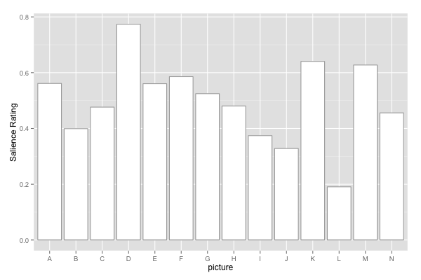
Figure 8. Results of the independent salience study.

A one-way ANOVA showed that rated salience differed significantly between 14 pictures, F(13, 546) = 6.44; p < 0.001 with picture D being rated the most prominent and picture L the least. This however did not correlate strongly with the picture means of memory scores. The only significant correlation of Salience Rating occurred with mean Back-to-the-Wall score (recoded this time as a picture-oriented variable, i.e. the ratio of participants who placed the given picture back on the correct wall) and this was valid only for the gallery visitors from the Condition 2. Correlations between specific memory tests are also worth noting as they were not observed in the location-oriented analysis. Table 2 presents the correlation matrix.

 | Both Conditions jointly |  |  | Condition 1 |  |  | Condition 2
 | RT | RT  accuracy | Back-to-  the-Wall | RT | RT  accuracy | Back-to-  the-Wall | RT | RT  accuracy | Back-to-  the-Wall
RT accuracy | -0.57* |  |  | -0.17 |  |  | -0.52
Back-to-the-Wall | -0.64* | 0.78*** |  | -0.25 | 0.73** |  | -0.39 | 0.32
Salience Rating | -0.26 | 0.2 | 0.32 | -0.17 | 0.24 | 0.01 | -0.21 | 0.14 | 0.56*

Table 2. Correlation matrix for picture-oriented variables.
p < 0.05*; p < 0.01**; p < 0.001***

DISCUSSION
The correlation between the results of both memory tests (the computer recognition test and the Miniature Task) in the picture-oriented analysis was not mirrored in the location-oriented calculations. This can be interpreted in the following way: the pictures which were recognised faster and more accurately on the computer recognition test tended to be placed back on the correct wall more often in the Miniature Task. If, however, participants could correctly (and quickly) recognise pictures from, say, location x108, it did not mean that content of this location would automatically be easier to recall in the Miniature Task. Hence, it can be assumed that, in the context of this study, the objects, and not locations, were the carriers of linked object-based and space-based information, although it must be noted that this result might be context-specific (Caduff and Timpf 2008). Once a picture was well-remembered, so was the spatial information relevant to it (although not necessarily in this chronological order). The role of spatial configuration in this situation is to facilitate the uptake of this information by exposing pictures in a particular way. Even the most prominent locations however would not guarantee that both types of memory traces would be enhanced for pictures placed on them. This again signifies the importance of separating both types of memory for objects in real-life spaces. Further analyses shed more light on this interrelation.
Condition 1 resulted in faster RT for pictures seen inside the gallery than experiencing the same gallery in Condition 2. The recognition test was designed to measure object-oriented memory and was linked in our results to the size of the Visibility Catchment Area. This effect was, however, only valid for Condition 2, whose participants performed worse on the task and where the average VCA was smaller. Smaller mean VCA is the consequence of many pictures being located close to room corners, or with a restricted space in front of them. A possible explanation of the result is that, assuming any random walking path through the environment, higher mean VCA indicates that the pictures had higher probability of falling within a comfortable viewing zone of each visitor for longer. This seems not to play a large role when viewing conditions are comfortable (large VCA, separated pictures in Condition 1), but to only become an inhibiting factor when VCAs become severely limited. The relation therefore seems to be non-linear, and there might be a certain threshold of average-VCA-to-area ratio involved, which constitutes the boundary between comfortable and uncomfortable viewing conditions.
Our Miniature Task did not provide conclusive results for the Condition 2. A large spread might be indicative of extreme difficulty and as such was already a problem noted in relation to other spatial memory tasks (von Stülpnagel and Steffens 2012). In Condition 1, this score was however negatively correlated with number of objects within the location's isovist. The number of other locations within the isovist is indicative of the possible co-visibility of other objects during the investigation of a single picture from a close range, as often occurs in the art gallery context. Since the Miniature Task was designed with the idea of establishing the memory performance for inter-object relations, it seems surprising that noticing other objects around would inhibit the successful completion in this task. Perhaps a higher likelihood of being distracted is not beneficial for establishing links between objects and their locations in space. Such an explanation could also clarify the large spread of this variable's results among participants from Condition 2. The significant correlation of the Salience Rating with Back-to-the-Wall score in Condition 2 indicates that it was the picture's salience that driven participants' spontaneous spatial memory in the situation in which space was designed to interrupt rather than help in a comfortable viewing. Our suggested explanation is that Condition 1 allowed for an easy one-to-one mapping between the object and its spatial unit, which caused faster reaction times in the recognition test. This would remain in line with the Janzen's (Janzen 2006) interpretation of her own results. When spatial relations become less obvious, perhaps confusing, and when the potential for distraction rises, perceptual salience starts to play a significant role in directing human spontaneous memory in a gallery setting.
As a note of conclusion, it is important to emphasise that comfortable (or 'cognitively efficient') space itself does not seem to greatly help in enhancing the memory, but badly designed can become a major inhibiting factor. However, our data does not allow us to determine where the boundaries of 'badly designed gallery' lie. Space can then shift the potential outcome of a cautiously prepared, curated exhibition into the one driven mainly by the objects' visual importance. At the same time however, it need not to be ignored that creating such a situation might form part of an artist's intention (Dorsett 2010). Therefore it would be difficult to suggest design practices leading to the emergence of a perfect exhibition space. It is much more realistic, and potentially useful, to propose how to consciously control such spaces and how to avoid their unwanted configuration, as presented in this work.

REFERENCES
Baxandall, Michael. 1991. “Exhibiting Intention: Some Preconditions of the Visual Display of Culturally Purposeful Objects.” In Exhibiting Cultures: The Poetics and Politics of Museum Display, ed. Ivan Karp and Steven D. Lavine, 33–41. Washington and London: Smithsonian Institution Press.
Bellamy, Susi. 2012. “Strike a Pose”. Digital images from a collage. http://www.susibellamy.com.
Benedikt, M.L. 1979. “To Take Hold of Space: Isovists and Isovist Fields.” Environment and Planning B: Planning and Design 6: 47–65.
Bitgood, Stephen. 2010. An Attention-value Model of Museum Visitors. Center for the Advancement of Informal Science Education. http://caise.insci.org/uploads/docs/VSA_Bitgood.pdf.
Buchner, Axel, and Petra Jansen-Osmann. 2008. “Is Route Learning More Than Serial Learning?” Spatial Cognition & Computation 8 (4) (December 11): 289–305.
Caduff, David, and Sabine Timpf. 2008. “On the Assessment of Landmark Salience for Human Navigation.” Cognitive Processing 9 (4) (December): 249–67.
Chan, Edgar, Oliver Baumann, Mark Bellgrove, and Jason Mattingley. 2012. “From Objects to Landmarks : the Function of Visual Location Information in Spatial Navigation.” Frontiers in Psychology 3 (August) (January): 304.
Choi, Yoon Kyung. 1999. “The Morphology of Exploration and Encounter in Museum Layouts.” Environment and Planning B: Planning and Design 26 (2): 241–250.
Dalton, Sheep, Paul Marshall, and Ruth Conroy Dalton. 2010. “Measuring Environments for Public Displays : A Space Syntax Approach.” In CHI ’10 Extended Abstracts on Human Factors in Computing Systems, 3841–3846. New York: ACM.
Dorsett, Chris. 2010. “Making Meaning Beyond Display.” In Museum Materialities: Objects, Engagements, Interpretations, ed. Sandra H. Dudley, 241–259. London and New York: Routledge.
Han, Xue, Patrick Byrne, Michael Kahana, and Suzanna Becker. 2012. “When Do Objects Become Landmarks? A VR Study of the Effect of Task Relevance on Spatial Memory.” PloS One 7 (5) (January): e35940.
Hillier, Bill, MD Major, J Desyllas, K Karimi, B Campos, and T Stonor. 1996. Tate Gallery, Millbank: a Study of the Existing Layout and New Masterplan Proposal. UCL (University College London). http://discovery.ucl.ac.uk/932/1/hillier-etal-1996a_TateGallery.pdf.
Hillier, Bill, and Kali Tzortzi. 2007. “Space Syntax: The Language of Museum Space.” In A Companion to Museum Studies, ed. Sharon Macdonald, 282–301. Blackwell Publishing Ltd.
Hollingworth, Andrew. 2008. “Visual Memory for Natural Scenes.” In Visual Memory, ed. Steven J. Luck and Andrew Hollingworth, 123–162. Oxford: Oxford University Press.
Ishihara, Shinobu. 1917. Test for Coiour-Blindness. Tokyo: Hongo Harukicho.
Itti, Laurent, and Christof Koch. 2000. “A Saliency-based Search Mechanism for Overt and Covert Shifts of Visual Attention.” Vision Research 40 (10–12) (June): 1489–1506.
Janzen, Gabriele. 2006. “Memory for Object Location and Route Direction in Virtual Large-scale Space.” Quarterly Journal of Experimental Psychology (2006) 59 (3) (March): 493–508.
Janzen, Gabriele, and Miranda van Turennout. 2004. “Selective Neural Representation of Objects Relevant for Navigation.” Nature Neuroscience 7 (6) (June): 673–7.
Johnson, Angie. 2011. “The Role of Goals and Attention on Memory for Distance in Real and Virtual Spaces”. PhD diss., Northumbria University.
Kaynar, I. 2005. “Visibility, Movement Paths and Preferences in Open Plan Museums: An Observational and Descriptive Study of the Ann Arbor Hands-on Museum. ” In Proceedings of the 2nd International Space Syntax Symposium. Delft.
Land, Michael F, and Benjamin W Tatler. 2009. Looking and Acting: Vision and Eye Movements in Natural Behaviour. Oxford: Oxford University Press.
Mathôt, Sebastiaan, Daniel Schreij, and Jan Theeuwes. 2012. “OpenSesame: An Open-source, Graphical Experiment Builder for the Social Sciences.” Behavior Research Methods 44 (2) (June): 314–24.
Miller, Jared, and Laura Carlson. 2011. “Selecting Landmarks in Novel Environments.” Psychonomic Bulletin & Review 18 (1) (February): 184–191.
Montello, Daniel R. 1998. “A New Framework for Understanding the Acquisition of Spatial Knowledge in Large-scale Environments.” Spatial and Temporal Reasoning in Geographic Information Systems: 143–154.
Münzer, Stefan, Hubert D Zimmer, Maximilian Schwalm, Jörg Baus, and Ilhan Aslan. 2006. “Computer-assisted Navigation and the Acquisition of Route and Survey Knowledge.” Journal of Environmental Psychology 26 (4): 300–308.
Newhouse, Victoria. 2005. Art and the Power of Placement. New York: The Monacelli Press.
O’Doherty, Brian. 1986. Inside the White Cube: The Ideology of the Gallery Space. San Francisco: The Lapis Press.
O’Neill, Michael J. 1992. “Effects of Familiarity and Plan Complexity on Wayfinding in Simulated Buildings.” Journal of Environmental Psychology 12 (4): 319–327.
Peponis, J, and J Hedin. 1982. “The Layout of Theories in the Natural History Museum.” 9H 3: 21–25.
Psarra, Sophia. 2009. Architecture and Narrative: The Formation of Space and Cultural Meaning. Routledge.
R Core Team. 2013. “R: A Language and Environment for Statistical Computing”. Vienna, Austria. http://www.r-project.org/.
Ratcliff, R. 1993. “Methods for Dealing with Reaction Time Outliers.” Psychological Bulletin 114 (3) (November): 510–32.
Schmidt, Constantin, J Müller, and G Bailly. 2013. “Screenfinity: Extending the Perception Area of Content on Very Large Public Displays.” In ACM CHI ’13.
Serrell, Beverly. 1997. “Paying Attention: The Duration and Allocation of Visitors’ Time in Museum Exhibitions.” Curator 40 (2): 108–125.
Stavroulaki, Gianna, and John Peponis. 2003. “The Spatial Construction of Seeing at Castelvecchio.” In Proceedings of the 4th International Space Syntax, 66:1–13. London.
Steck, SD, and HA Mallot. 2000. “The Role of Global and Local Landmarks in Virtual Environment Navigation.” Presence: Teleoperators & Virtual Environments 9 (1): 69–83.
von Stülpnagel, Rul, and Melanie C Steffens. 2012. “Can Active Navigation Be as Good as Driving? A Comparison of Spatial Memory in Drivers and Backseat Drivers.” Journal of Experimental Psychology-Applied 18 (2): 162.
Turner, Alasdair. 2001. “A Program to Perform Visibility Graph Analysis.” In Proceedings of the 3rd Space Syntax Symposium. Atlanta.
Turner, Alasdair, Maria Doxa, David O’Sullivan, and Alan Penn. 2001. “From Isovists to Visibility Graphs: a Methodology for the Analysis of Architectural Space.” Environment and Planning B: Planning and Design 28 (1): 103–121.
Tzortzi, Kali. 2003. “An Approach of the Microstructure of the Gallery Space: The Case of the Sainsbury Wing.” In 4th International Space Syntax Symposium. London.
Tzortzi, Kali. 2007. “Museum Building Design and Exhibition Layout.” In 6th International Space Syntax Symposium. Istanbul.
Vergo, Peter. 1989. “The Reticent Object.” In The New Museology, ed. Peter Vergo, 41–59. London: Reaktion Books.
Whelan, Robert. 2008. “Effective Analysis of Reaction Time Data.” The Psychological Record 58 (3): 475–482.
Wiener, Jan M, Gerald Franz, Nicole Rossmanith, Andreas Reichelt, Hanspeter A Mallot, and Heinrich H Bülthoff. 2007. “Isovist Analysis Captures Properties of Space Relevant for Locomotion and Experience.” Perception 36 (7): 1066 – 1083.
Wineman, Jean, John Peponis, and Ruth Conroy Dalton. 2006. “Exploring, Engaging, Understanding in Museums.” In Space Syntax and Spatial Cognition Workshop: Spatial Cognition ’06, 33–51.
Xie, H., L. Filippidis, S. Gwynne, E. R. Galea, D. Blackshields, and P. J. Lawrence. 2007. “Signage Legibility Distances as a Function of Observation Angle.” Journal of Fire Protection Engineering 17 (1) (February 1): 41–64.
Zamani, P. 2009. “Architecture as Curatorial Device.” In 7th International Space Syntax Symposium. Stockholm.

We refer to 'museums' as a general category, and to 'art galleries' as a subset of it. Where appropriate, works relating to all museums are referred, although this project's focus lies solely in 'art galleries'.
Many experimental designs restrict the participants by imposing a pre-defined path, walking pace, or by showing a video clip of the route instead.
The purpose of this was to ensure that non of the pictures seen inside has been actively sustained in participants' memory.
DepthMap's arbitrary units.

